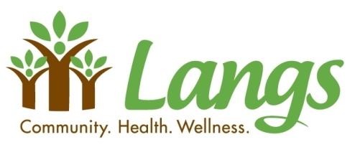
Gift Card Program 2025

Give your friends/family the perfect gift this year - gift cards! No line ups, no size issues and best of all, no returns!
By participating in this gift card campaign you are supporting Langs, as we will receive up to 10% in return on all orders.

Description | Denominations | QTY | Sub Total ($)
Bath & Body Works | 25
Canadian Tire | 25
Canadian Tire | 50
Cara (East Side Mario's, Harvey's, Kelsey's, Montana's, NYF, Pickle Barrel, Swiss Chalet) | 25
 | 50
Chapter's, Indigo, Coles | 25
Chapter's, Indigo, Coles | 50
Cineplex Gift Card | 25
Dollarama | 25
Esso, Mobil, On The Run | 25
The Gap | 25
Giant Tiger | 25
Happy Teen (Am Eagle, Ardene, Cineplex, Garage, Guess, Golf Town, HM, Indigo, Sportchek, Sephora) | 50
The Keg | 25
The Keg | 50
Kernals Popcorn | 10
Laura Secord | 25
LCBO | 50
Loblaws, No Frills, Zehrs | 25
Loblaws, No Frills, Zehrs | 50
Longos | 50
McDonald's Restaurants | 10
McDonald's Restaurants | 25
Metro, Food Basics | 25
Metro, Food Basics | 50
ONE4ALL | 25
Petro-Canada | 25
Shell | 50
Shoppers Drug Mart | 25
Sobeys, Foodland, FreshCo, | 25
Sobeys, Foodland, FreshCo, | 50
Starbucks | 10
Starbucks | 25
Tim Hortons | 10
Tim Hortons | 25
Walmart | 25
Walmart | 50
Walmart | 100
Winners, Home Sense, Marshalls | 25
Winners, Home Sense, Marshalls | 50
 | Total

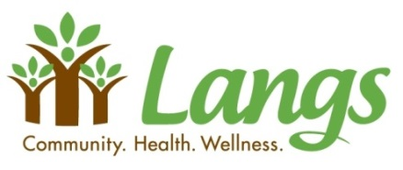
Please also complete the ‘Contact and Payment Info’ form

Contact and Payment Info

Name | Click or tap here to enter text.
Address | Click or tap here to enter text.
City | Click or tap here to enter text. | Postal Code | Click or tap here to enter text.
Email | Click or tap here to enter text. | Telephone | Click or tap here to enter text.

Payment Options
Cash☐ |  | Cheque☐ |  | E-transfer☐
Enclose with order  (do not mail) |  | Payable to  Langs Farm Village Association |  | katech@langs.org  Kate Calija, Director of Finance, Langs  (automatic deposit,  no password required)

Please return this form to Sarah MacTavish by Monday November 17th, 2025.
(in person or electronically to sarahm@langs.org – please DO NOT etransfer funds to Sarah)

Cards are expected to arrive at Langs December 5th, 2025.Cards are expected to be available for pick up the week of December 8th.

You will be notified when they are ready for pick up.

Langs: 1145 Concession Road, Cambridge, ON N3H 4L5
By email: sarahm@langs.org
For more information call: 519-653-1470, ext. 240

